ANANDWAR (FUN DAY)
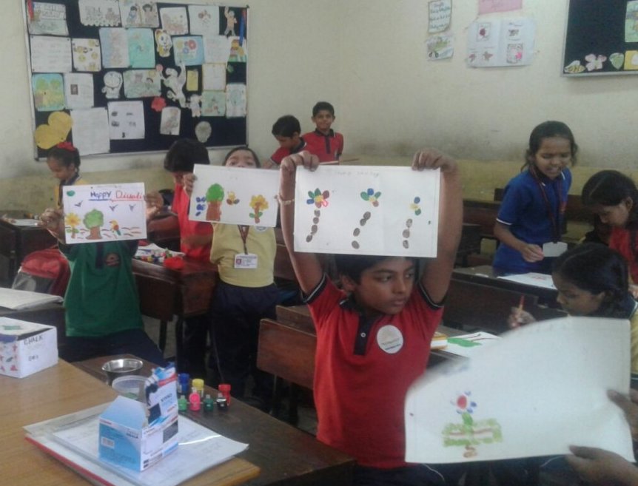
- Anandwar on Saturdays (except second Saturday) for classes I to V.
- Students need not carry the burden of school bag on Saturday rather they will carry only Lunch box and water bottle and have fun the whole day.
- Complete Fun Day, No Book Day..
- No text book teaching..
- Various extra-curricular activities to be conducted.

